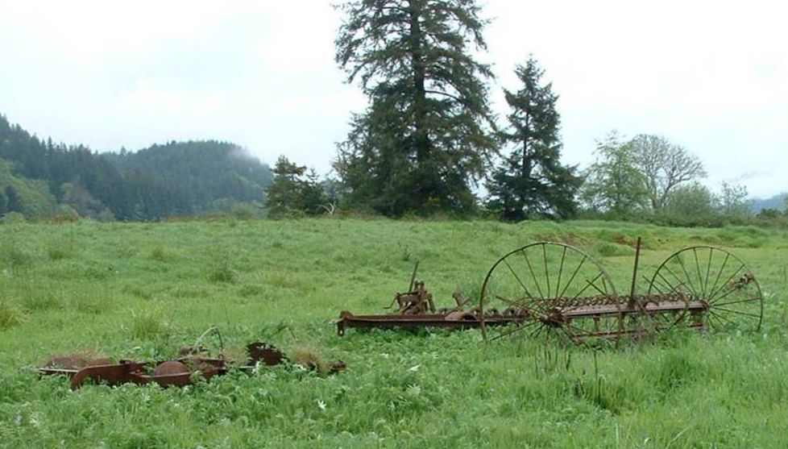
The Wilbur Island Mitigation Bank is a 140-acre wetland which had been tidally flooded prior to being diked in the 1950’s to create pastureland, and over the last several years has been restored to its natural state by protecting the neighboring properties, removing the dikes and restoring native vegetation. It provides a wide array of habitat conditions that are crucial to many species indigenous to the area, with several protected species including Coastal Coho Salmon. Restoring & protecting the habitat on this 300-acre island is crucial for fish such as salmon and steelhead for acclimating between freshwater & the ocean.
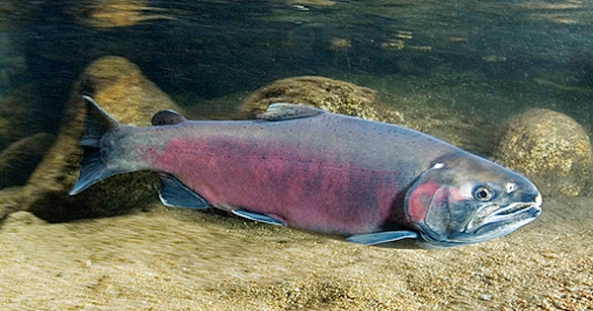
*Photo credit: NOAA Fisheries Service, Southwest Fisheries Science Center
Several studies have identified the area as having a very high preservation value, with the western portion being identified as the ‘second largest relatively undisturbed tidal marsh in the Siuslaw estuary,’ receiving the highest possible score for Salmonid Diversity.
(Brophy 2005)

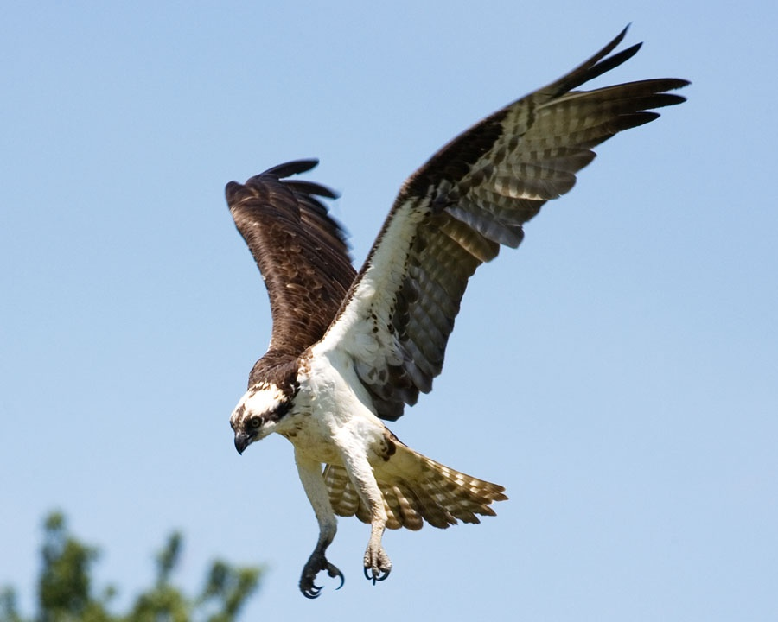
*Photo credit: Tracie Kovener

CONTACT US
for further information:

Wilbur Island Mitigation Bank
Megan Gerber, Office Manager
Don Wilbur Ltd. Partnership
PO Box 40 / 15120 Hwy 36
Deadwood, OR 97430

www.donwilbur.com
Office: 541-964-3345
Toll-Free: 877-964-3345
Email: dwilbur@casco.net

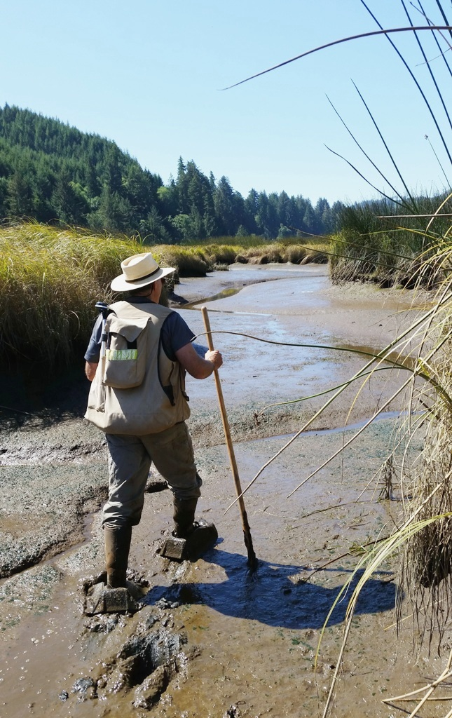
*Photo credit: Dick Brainerd
Wilbur Island
Wetland
Mitigation Bank

Siuslaw River estuary
Cushman, Oregon

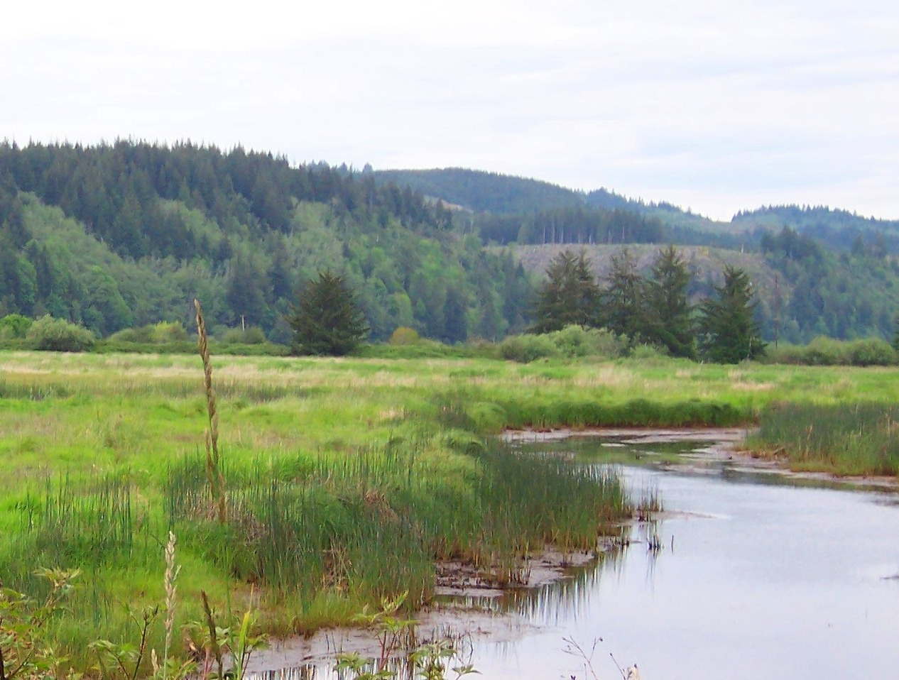

Wilbur Island Mitigation Bank is…
- Providing critical habitat and perpetual protection for migrating and indigenous species such as
Oregon Coast Coho Salmon,
Chinook Salmon,
Steelhead (anadromous Rainbow Trout),
Eulachon, Pacific Lamprey, native Eelgrass, amphibians, and many shore birds, game birds and birds of prey…

- Balancing conservation, property rights and development concerns in a responsible and sustainable way…

- Part of a sensible environmental solution for Oregon’s Central Coast!

